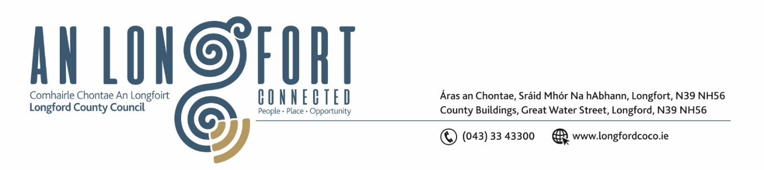

**LONGFORD MUNICIPAL DISTRICT**

***Please note meeting will be held in the Council Chamber, Aras an Chontae and via Microsoft Teams***

**15 February 2023.**

**To: Each Member of Longford Municipal District.**

**Dear Member,**

You are requested to attend the Meeting of Longford Municipal District to be held in **the Council Chamber, Aras an Chontae** and **via Microsoft Teams** on **Wednesday 22 February 2023 at 3.30pm** to transact business, as set out on the agenda hereunder.

**Yours sincerely**,

_______________

**Claire McNabola**

**Meetings Administrator**

**AGENDA**

Prayer before meeting.

**1.** Confirmation of Minutes:

1. Longford Municipal District Meeting held on Wednesday 25 January 2023 – enclosed.

**2.** Matters arising from Minutes.

**3.** Declaration of Interest by Members.

**4.** Management Report – enclosed.

**5.** Review of By-Laws

**6.** Longford Greyhound Track Project update

**7**. Update on Recommended Minimum Criteria for Environmental Inspection (RMCEI)

**8.** St Patrick’s Day Parade

**9.** **Notices of Motions, submitted by Councillors, as listed hereunder –**

**Councillor Gerry Warnock**

I am calling on Longford Municipal District to commence the process for the formal “Taking in Charge” of the infrastructural roads, public lighting and storm water services at Palace Crescent, Ardnacassa, Longford.

**Councillor John Browne**

In the interest of Public Safety, I call on Longford County Council to have Public Lighting installed between the Leo Casey Roundabout and the Red Cow Roundabout.